Nathan Bemus

ECCS 4361

Homework 6

10/11/17

Task 1: Down sample and reconstruct an image in YCbCr Representation:

I started this task by reading in an image and I saved all of the dimensions of the image into separate variables for height and width.



The following matlab code shows how I did this.

im =imread('south_park.jpg');

figure(1);

imshow(im);

width = 1296;

height = 730;

I next converted the image into YCbCr. This the resulting image for the transformation.

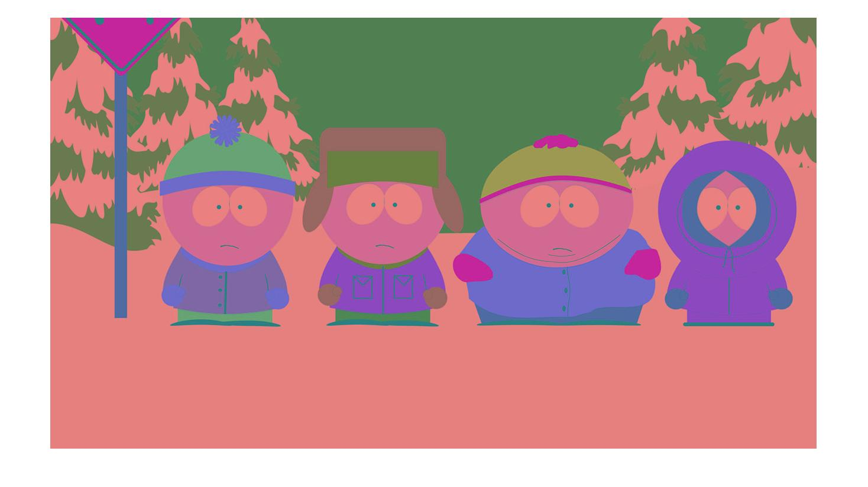

The following matlab code shows how I was able to manipulate the image.

imYCBCR = rgb2ycbcr(im);

figure(2)

imshow(imYCBCR);

I then down sampled the Cb and Cr components of the image and stored them into separate images. The following matlab code shows how I got the individual components.

CB = zeros(height/2, width/2);

CR = zeros(height/2, width/2);

for i = 1:height/2

for j = 1:width/2

CB(i,j) = imYCBCR(i*2, j*2, 2);

CR(i,j) = imYCBCR(i*2, j*2, 3);

end

end

figure(3)

imshow(uint8(CB));

figure(4)

imshow(uint8(CR));

The following image is the image created by the Cb component.

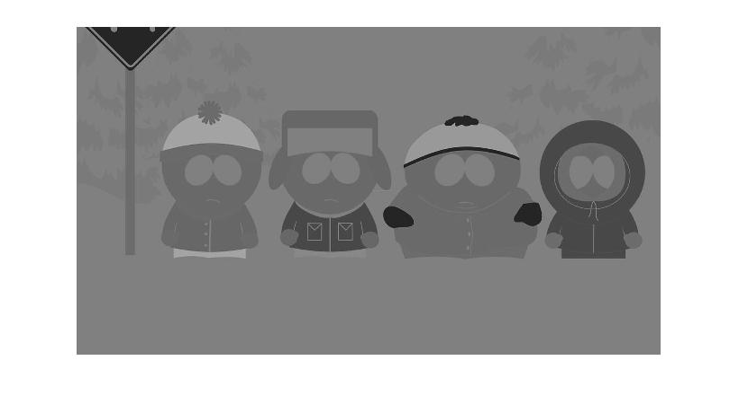

The following image was created by the Cr component.

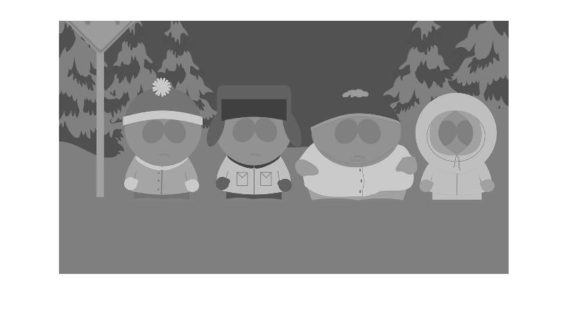

Next I then

tScale = affine2d([2 0 0; 0 2 0; 0 0 1]);

bigCB = imwarp(CB, tScale, 'bicubic');

bigCR = imwarp(CR, tScale, 'bicubic');

reconstructed = zeros(height, width, 3);

reconstructed(:, :, 1) = imYCBCR(:, :, 1);

reconstructed(:, :, 2) = bigCB;

reconstructed(:, :, 3) = bigCR;

reconstructed = ycbcr2rgb(uint8(reconstructed));

figure(5)

imshow(uint8(reconstructed));